Training: Never Plateau Again
Break through performance barriers with tips from the pros
By Neely Quinn / Illustrations by Skip Sterling
Climbing is addictive. One reason is that you can see massive strength gains and technique improvement from day one of your climbing career. But after a few months—or for the extremely lucky, a few years—a plateau can sneak up on you, slow your progress, and frustrate you beyond belief. During my own personal three-year-long plateau, I heard every kind of advice from doing more pull-ups to climbing every day despite the pain to even going vegetarian (not gonna happen). On a quest to find the one true way, I started to interview top climbers to see how they handled these annoying performance flatlines—both mentally and physically—and the answers I found were as diverse and interesting as the climbers themselves.

Focus On:

Nutrition and Healthy Body Weight
Weight has always been a tricky topic for climbers. There was a time when starving yourself seemed the norm, and strong climbers sacrificed much-needed muscle mass to be as light as possible. Today, it’s common knowledge that eating too little is not only counterproductive to becoming a better climber, but it’s also detrimental to your overall health. To figure out if you’re at a healthy weight, or over or underweight, figure out your body mass index (BMI) with bmi-calculator.net. This can give you a good idea of how much fat you can stand to lose—if any. Remember that the BMI system does have its flaws; sometimes the super-fit and muscular folks can score overweight. The ultimate judge of your weight and food intake lies in your climbing performance and how you feel on a daily basis.
The next step is to figure out how much you should be eating. Trymyfitnesspal.com, a free online diet tracking tool that uses your weight, height, gender, and activity level. Using those estimated calorie needs as a guideline, track your diet on the site to see how much you should eat every day. Just a few days of tracking can give great insight into how much food you’re eating, and how much of it is unnecessary. This will help you strike the fine balance between eating too little to stay light and eating enough to stay strong and energized.
So, what to eat? Whole foods like lean meats, vegetables, fruit, and whole grains are crucial to maintaining a healthy weight. One trick from 5.14 climber and trainer Mike Anderson is to eat a ton of low-density foods like vegetables. He eats an enormous salad with veggies, meat, and healthy fats (avocado, olive oil) at least once a day; it provides plenty of nutrients and keeps him full for hours, thanks to the fiber, protein, fat, and bulk it provides. Fat loss can be accelerated by cutting back on carbs. Every climber needs carb energy, but we don’t need as much as what a common American diet delivers (bagel for breakfast, sandwich at lunch, pasta for dinner, etc). This will result in storing less of those unused calories as fat.
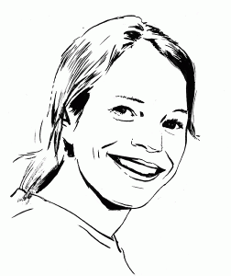Angie Payne: “I went through a ‘light’ phase. I was climbing way too much, and not eating enough. I knew I was losing weight, but I didn’t know I was losing that much. It was a pretty vicious cycle. It wasn’t really sustainable, and I didn’t have very much energy at all. It feels good to feel light, and when you’re pretty small you feel that more often. But after a while, I realized that the feeling of being strong is a lot cooler than feeling light, and they’re very different.”

Strength Training
Most climbers hate to spend training time off of the wall, but adding one or two specific exercises, including hangboard workouts, after your climbing session can produce major results. If you’re short, wide-grip lat pull-downs at maximum weight can give you extra reach and improve lockoff strength. Find a lat pull-down machine (most gyms have them), and widen your grip as far as possible—wider than your shoulders. Experiment with weight until you’re failing on your third rep. Then do three to five sets of two reps (failing on your third) at that weight with five minutes of rest between sets. Do these after a climbing session or on an off-climbing day; don’t do them before your session because you’ll be tired on the wall and won’t maximize your climbing time. Start with three times a week, moving up in weight as you get stronger. You can do more sessions in a week, but if you find yourself too tired to climb hard during your session, scale back to three.
Trainer and author Steve Bechtel is a huge proponent of weightlifting, hangboarding, and campusing as specific training for rock climbing. He says, “I am becoming more and more convinced that if you simply develop a base strength, everything else falls into place.” Thinking about incorporating running into your training? Think again. Bechtel thinks it’s a waste of time for climbers. Instead, focus on the obvious: climbing, hangboarding, campusing, weighted pull-ups—and the not-so-obvious: squats and walking lunges. Try lunges or squats twice a week to strengthen your legs and core. These will improve your overall performance, but they’ll especially give you more strength and power for dynos where the initial push comes from your lower half. Multiple professional climbers have touted the hangboard as their catalyst for bumping up grades. As you move up in grades, holds get smaller, slopier, and generally crappier, and finger-strength training will make these holds feel easier to use and hang from. Think of it this way: If you can reach a hold to touch it, you will be able to grab it, and if you can grab it, you can hold on. See Digit Dialing for some workout ideas.
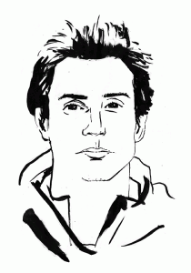Carlo Traversi: “I doubled the number of V13s I had climbed and did a few V14s when I incorporated max-weight, wide-grip lat pull-downs into my training regimen four to five times a week. My personal record was 260 pounds, which was almost twice my weight. As a short climber, I often need to be able to lockoff incredibly wide, and lat pull-downs were my solution.”

Weaknesses
It’s easy to have fun by focusing on what you’re good at; it’s much more difficult to face the fact that you’re not good at certain things, and then go out and turn them into strengths. Below are some common issues I found among the pros when it came to weaknesses.
>>Bad Footholds. Seek out the worst possible footholds in the gym and practice using them in a variety of ways, moving in all directions. Do the same outside and find problems that are known for glassy, microscopic, terrible feet.
>>Small Hands, Big Holds. Women tend to be good at crimping the tiniest nubs, but when it comes to large slopers and pinches, the ladies more often struggle. The only way to become proficient with these sizeable holds is by using them. Shannon Forsman is a short but very strong V12 boulderer and climbing coach. She encourages women to at least try difficult climbs that aren’t just crimps: “All I’m asking is for you to try something out of your comfort zone, whether it involves slopers, pinches, or even—gasp—a jump move. Just try! It might be difficult and embarrassing to project a couple of V-grades lower than you’re used to, but over time you’ll come out a much stronger climber.” She says finger strength isn’t the only factor for open-handed holds; success can depend on how well you use the rest of your body. “Slopers require patience, balance, core tension, and very subtle movement; every limb must be engaged. You don’t just grab slopers, you use the rest of your body to position yourself in a way that makes them useable. A general rule of thumb is to stay as far below slopers as possible so that you are pulling down rather than out.”
>>Power. No matter how many laps you can run on techy moderates, you will inevitably plateau at a more difficult grade if you don’t have power. Try circuits on hard boulder problems instead of just climbing around randomly. The campus board and systems board are also especially useful. Consider adding a few sets of simple box jumps (repeatedly jump on an 18” to 24” sturdy box) after climbing sessions. It will give you the explosive leg power and muscle memory you need for big moves.
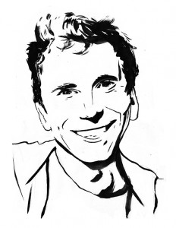Jonathan Siegrist: “I could run lap after lap on sport routes just below my max ability, but power always eluded me. My training volume has gone down, but my training intensity has gone up. I do limit bouldering, so short, hard problems [that have one or two crux moves at your limit], and campusing, which is really important. I do one to three campus board sessions per week that last two hours each.”
Note: Due to altering his training to focus on power, resting more often than he used to, and quitting his running habit altogether, Siegrist broke a three-year climbing plateau by nabbing 5.14d ascents in a few tries and sending his first 5.15a, the historic and legendary Realization, also called Biographie, in Ceuse, France.

Failure and Redpointing
When climbing at a world-class level, professionals are constantly faced with failure. Each pro climber has had to develop his or her own positive attitude, along with mental coping mechanisms. Studies that focus on the psychological aspect of sports show that the best athletes are those who can successfully “lie” to themselves, meaning they can internally say, “Yeah, I can do that. Doesn’t matter that I sucked just now—I can totally do this. No problem.” Even if something is beyond your current ability or strength level, it’s best to approach it with blind optimism and confidence (within reason, of course). Carlo Traversi has a refreshingly positive and simple outlook, saying, “There are so many failures in climbing. I try not to dwell on them. I climb because it’s fun.”
All of these pros have spent months—sometimes years—on particular projects. This means returning to the same crag over and over with an upbeat attitude and a desire to go back for more. With any luck on a project, you’ll be falling off higher and higher up, but if you aren’t, the Anderson brothers (authors of The Rock Climber’s Training Manual) say you should get back in the gym and do a strength- and power-focused training cycle to get stronger. They say sometimes it’s best to step away from the rock, even if it means not getting the send that season. Whitney Boland, a 5.14 climber, says she gets anxious or scared before certain moves, especially big, dynamic ones since she’s short (5’ ½”). She recommends just going for it as a way to push through. She says, “When you get to a move like that, decide you want to stick it and go for it. More often than not, you’ll surprise yourself. Even if you don’t hit the move and take a fall, you can feel proud of the fact that you really went for it, and then you can work on adjusting for the next attempt.”
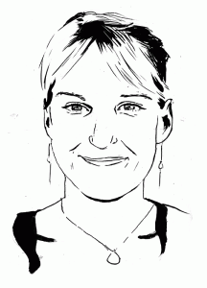Emily Harrington: “After a few months in the big mountains, I returned to sport climbing, and it was demoralizing to start all over. My secret was finishing every day by giving it everything I had, even when it bruised my ego. I would fall on climbs that were warm-ups. I reminded myself why I do this sport and what makes me love it so much. All you have to do is put in the time and effort. In the end, it’s all about wanting it.”
Heather Weidner: “It takes tremendous will to persevere through repeated failure. The best advice I can offer is don’t give up. Be headstrong. My hardest routes have taken me months of consistent work, and it is often painstaking to put in another burn that ends in failure. To get through the frustration, it helps me to focus on the small victories instead of the end result. I celebrate getting a new high point or figuring out more efficient beta.”

Breathing
The simple act of concentrated and thoughtful breathing can make everything feel easier. When you reach a difficult section on a climb, your breathing becomes shallow and rapid, which will decrease your body’s overall efficiency and can even make it hard to think straight. Start taking slow, even, and deep breaths before you leave the ground, and continue to force these breaths as you climb. Make them loud if it helps you concentrate on it. Practice will help you find the balance between breathing too rapidly and too slowly. Smooth, calm breathing is a simple solution for better performance.
Paige Claassen: “I leave the ground with one big breath and then maintain a steady pattern of deep, consistent breaths throughout my climb. It provides more oxygen to your muscles to ward off pump. I think about making my breathing audible and rhythmic. If I can hear it, I will focus on keeping it even and deep. All I can hear is my breath, and it has become a comfort as I climb, distracting me from fear and doubt. Plus, I immediately notice if I stop breathing.”
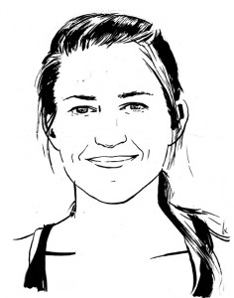Neely Quinn is a paleo nutritionist and climber who works online from the road. She and her husband, Seth Lytton, created trainingbeta.com for mortal rock climbers who want useful training advice and programs that are easy to follow.

